Task 2 - Eras geogebra
Squares around parallelogram

Given information: Any parallelogram ABCD

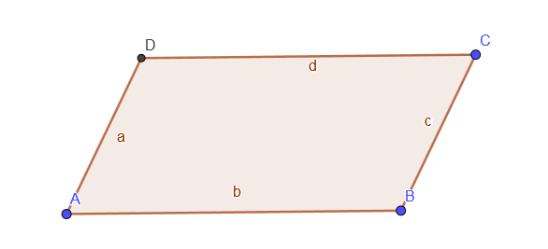
1) Construct 4 squares on 4 sides of a parallelogram
2) Consider the centres of these squares.

Task: What can you tell about the quadrilateral formed by these 4 centres?

